

Evaluation of species and sites for establishing seed islands, Waikereru Ecosanctuary, Tairawhiti

Michael Bergin and David Bergin
March 2022

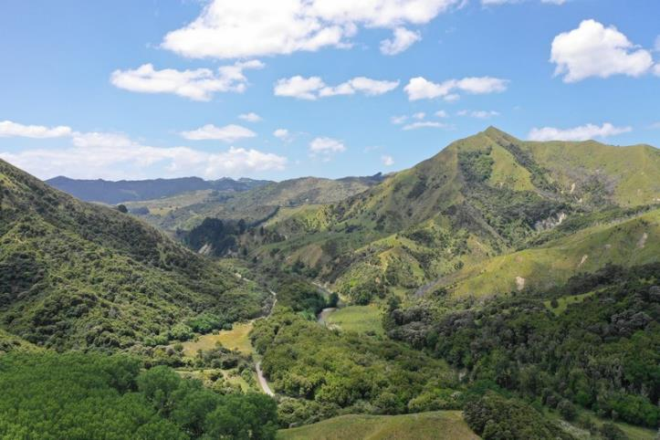
View north of the Waimata River valley with Waikereru Ecosanctuary on the left and the Longbush Reserve on the river terraces centre.

Introduction
The Longbush Ecological Trust has a 3-year project to demonstrate how to speed up succession of kānuka scrub into a diverse native forest in the Tairawhiti region as a way of tackling climate change, biodiversity losses and the restoration of waterways. This will be located at the Waikereru Ecosanctuary is over 100 ha of mostly regenerating hill country adjacent to the Longbush Reserve in the Waimata River valley approximately 10 km north of Gisborne.
A 3-year project is underway to set up planted "seed islands" of selected native trees and shrubs to rapidly increase biodiversity in the Waikereru Hills, with the aim of better understanding how most effectively to accelerate succession from shrubland to diverse native forest.
A botanical survey and mapping of mapping of the landforms of the Waikereru Ecosanctuary is underway to provide a context for monitoring natural regeneration and establishment of a network of seed islands. Other work includes ongoing pest animal (both browsers and bird predators) and selective weed control as necessary to support the regeneration of the Waikereru Hills. The aim is to share the findings of this work with the wider community through workshops associated with the Waimatā River restoration project and the Wildlab/Tiaki Taiao wilderness education programme at Waikereru.
The project is funded by the Lotteries Board with support from owners Anne and Jeremy Salmond, Trees That Count, research associates from Manaaki Whenua, NZ Landcare Trust, and Waimata River restoration landcare group. Nursery seedlings were partially funded by Trees That Count (TTC). The planting site at Waikereru Ecosanctuary has been registered as a TTC planting site and sample plots established to monitor early performance.

Previous work
The owners have been undertaking an active programme of restoration of their 100 ha property over the last 20 years including retirement of all of the steep hill country, fencing our domestic grazing stock and pest browsing animals, undertaking pest animal trapping, and planting of selective native trees and shrubs. With the change in landuse from extensive grazing, substantial areas of the hill country are naturally regenerating in predominantly kanuka with a diversity of shrub and small tree hardwood species largely confined to within steep gullies.
Some of the early planting provides insights into the current project aimed at demonstrating how to establish seed islands as a method for increasing diversity of key native tree and shrub species to encourage development of high native forest from bird and wind dispersed seed. This has included the establishment of single species groves of selected native tree species planted by the owners, and more recently planting of a wide range of species along lower slopes supported by Trees That Count.

Trees That Count plantings
Planting
In mid-2019 450 native trees and shrubs were planted by Ecoworks into sprayed spots at the toe of a hill slope within an extensive grassed clearing toward the southern end of the property (Figure 1). These trees were partially funded by Trees That Count and nine monitoring plots were established.

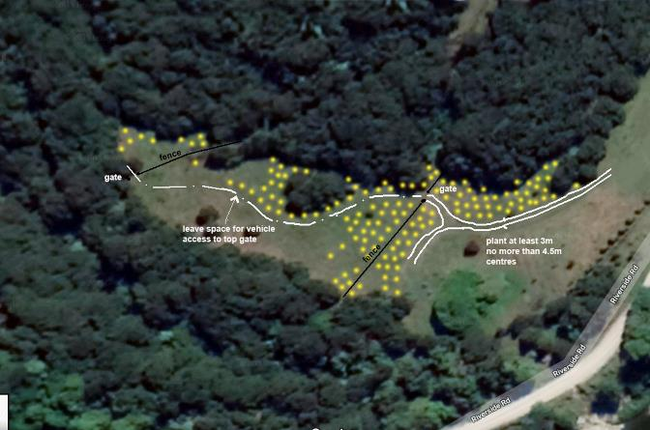
Figure 1: Approximate planting sites for the native trees and shrubs planted by Ecoworks in mid-2019 within a grass clearing at the southern end of Waikereru Ecosanctuary (Image source, Ecoworks).

Seedlings were supplied by the Native Garden Nursery in Matawhero (Table 1). Seedlings were grown in containers, either RX90 or 1.5L grades.

Table 1: Seedlings supplied for planting in mid-2019 at Waikereru Ecosanctuary, partially funded by Trees That Count.
Trees/  shrubs | Māori name | Botanical name | No. plants based on nursery order
Trees | Totara | Podocarpus totara | 25
Trees | Rimu | Dacrydium cupressinum | 25
Trees | Matai | Prumnopitys taxifolia | 25
Trees | Rewarewa | Knightia excelsa | 25
Trees | Kowhai | Sophora tetraptera | 25
Trees | Puriri | Vitex lucens | 25
Trees | Kohekohe | Dysoxylum spectabile | 25
Trees | Northern rata | Metrosideros robusta | 25
Trees | Tawa | Beilschmiedia tawa | 25
Shrubs | Karamu | Coprosma robusta | 50
Shrubs | Ti kouka | Cordyline australis | 50
Shrubs | Kohuhu | Pittosporum tenuifolium | 50
Shrubs | Tarata | Pittosporum eugenoides | 50
Shrubs | Wharangi | Melicope ternata | 50
Shrubs | Koromiko* | Veronica stricta var. stricta | 50
*Planted after the main planting in 2019 as replacements

Koromiko was used to blank up where earlier plantings had failed. Titoki was also planted but sample numbers in monitoring plots was too small to report performance.

Assessment
Nine plots were established using the methods developed by Trees That Count to monitor survival and early growth of planted natives (Bergin et al. 2021). Each plot was a 10 m diameter bounded plot with a permanent central treated wooden 50x50mm peg (Figure 2).

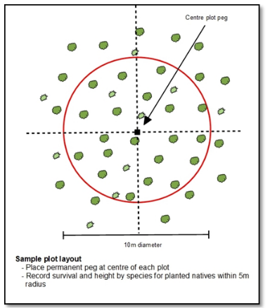
Figure 2: A circular 10m diameter plot for sampling planted natives developed to use for Trees That Count registered plantings.

Within 3 months of planting, all planted seedlings were recorded by species within each plot including height and plant vigour using a 1-5 scale subjective score of plant health. Plots were remeasured 2.5 years after planting and data analysed.

Early results
The performance of the planted native trees and shrubs 2.5 years after planting, based on the plot-based monitoring system developed by Trees That Count, is given in Table 2 and Figure 3. While the plots are placed across a representative area of the planting site, the random nature of planting species results in a variable number of plants per species sampled.

Based on survival 2.5 years after planting, the best performing tree species where 10 or more plants were sampled include the trees totara, matai and northern rata, and for shrubs ti kouka, kohuhu and tarata with greater than 85% survival. Except for matai, which is known to be slow growing, these species had good increment in height growth ranging from 79-124 cm in the first 2.5 years since planting.

While sample sizes were smaller, puriri, rewarewa and ti kouka also had high survival and were amongst the fastest growing, especially puriri with 148 cm height growth in less than 3 years since planting.

Plant vigour remained high for all species with kowhai, kohekohe and koromiko below the top score of 5 (Table 2, Figure 3).

Table 2: Performance of planted native trees and shrubs at Waikereru Ecosanctuary 2.5 years after planting based on 9 sample plots.
Trees/  shrubs | Species | No. plants (at planting) | Survival  (%) | Mean height  (cm) | Height range (cm) | Height increment* (cm) | Plant vigour** (1-5)
Trees | Totara | 13 | 85 | 105 | 72-130 | 79 | 5.0
Trees | Rimu | 10 | 60 | 129 | 111-158 | 61 | 5.0
Trees | Matai | 13 | 100 | 109 | 76-140 | 44 | 5.0
Trees | Rewarewa | 5 | 100 | 153 | 103-180 | 113 | 5.0
Trees | Kowhai | 10 | 50 | 93 | 39-174 | 42 | 4.8
Trees | Puriri | 4 | 100 | 209 | 190-230 | 148 | 5.0
Trees | Kohekohe | 11 | 18 | 94 | 85-103 | 16 | 4.5
Trees | Northern rata | 14 | 86 | 126 | 80-154 | 85 | 4.9
Trees | Tawa | 9 | 44 | 60 | 33-83 | 32 | 5.0
Shrubs | Karamu | 28 | 71 | 137 | 72-240 | 112 | 5.0
Shrubs | Ti kouka | 8 | 100 | 151 | 130-200 | 108 | 5.0
Shrubs | Kohuhu | 27 | 85 | 160 | 78-295 | 122 | 5.0
Shrubs | Tarata | 21 | 100 | 157 | 46-208 | 124 | 5.0
Shrubs | Wharangi | 47 | 21 | 134 | 70-205 | 87 | 5.0
Shrubs | Koromiko*** |  |  | 52 | 30-70 | 52 | 4.5
 | Average | 15 | 75 | 126.5 | 84.7 | 81.1 | 4.9
*Height increment after 2.5years
**Plant vigour score:1=poor, 2=unthrifty, 3=average, 4=good, 5=excellent
***Planted after the main planting in 2019 as replacements, therefore no survival figure

Figure 3: Mean survival, height increment and plant vigour 2.5 years after planting for the 14 native tree and shrub species planted at Waikereru Ecosanctuary.
The poorer performing species included kohekohe, tawa and wharangi, with rimu and kowhai of only moderate performance (Table 2, Figure 3). As later successional species, tawa, kohekohe and rimu do not establish naturally on open sites and wharangi prefer sheltered lowland sites. Observations indicated there was increased survival of these poorer performing species where they were planted along the edge of the grassed clearing likely benefiting from the adjacent kanuka.

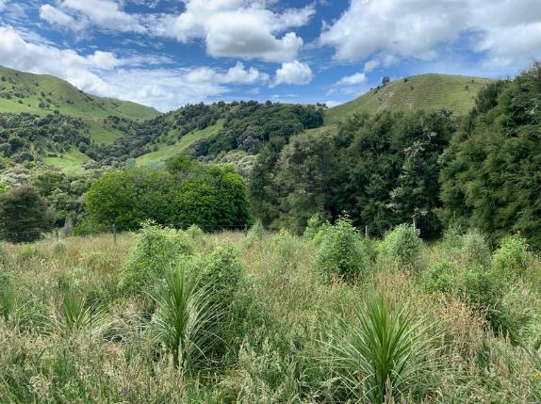
An open site within the TTC planting established 2.5 years ago with shrub hardwood and tree species. Dense grass dominates the open areas and is released once or twice a year.

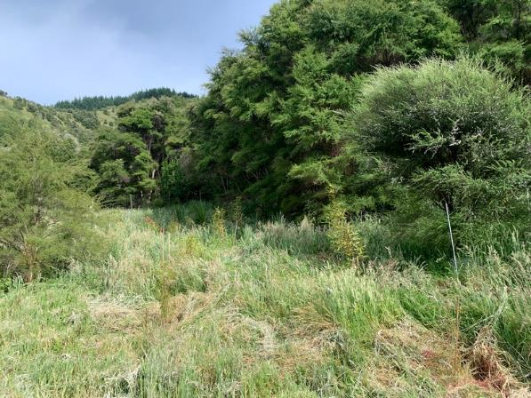
A planting site that shows the existing natural kanuka 6-8m high that surround the new plantings providing beneficial shelter.

Recommendations for seed islands
With an average of 75% survival across the 15 tree and shrub species planted, and annual height increments of 30 cm and more for most shrub species and many tree species, this planting has provided a useful guide for selection of species and targeting site types to suit ecological preferences for planting in seed islands.

For seed island on relatively open grass sites, species to plant include:
- Shrubs – kohuhu, tarata, ti kouka, with some karamu to provide early fruiting.
- Trees – totara, rewarewa, puriri, northern rata and matai.

For seed islands located in canopy gaps within exiting naturally regenerating kanuka, additional species to include:
- Shrubs – wharangi, koromiko
- Trees – rimu, tawa, kohekohe, kowhai.

There are other native tree and shrub species which have been ordered for planting in seed islands and will be targeting specific sites for planting based on ecological preferences. For seed islands in open areas or large canopy gaps this includes the shrubs ngaio and makomako, and for more sheltered sites whauwhaupaku/five finger and trees titoki, kahikatea for low lying sites and black beech.

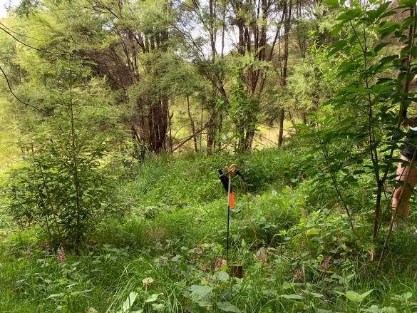
One of the TTC 2019 planting plots was located within a gap in the existing natural kanuka, the shrub hardwood and trees planted here have very good survival and growth rates.
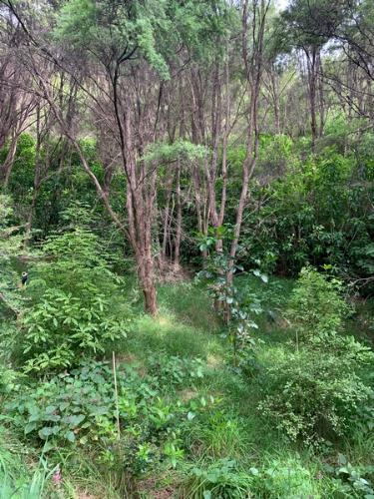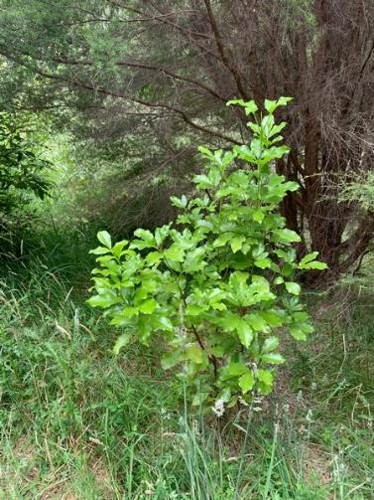
Puriri, titoki, kohuhu, karamu and wharangi were very impressive.

Scoping sites for seed islands
A reconnaissance of the lower slopes above the pa-harakeke garden and older native tree plantations was undertaken in December 2021, scoping the various sites within the existing kanuka as possible sites for the planting of seed island plots in open grassed sites. Potential sites for locating seed islands were evaluated and assigned to one of three cover classes:
- Open site within a large canopy gap
- Partial shade with scattered kanuka, and
- Enclosed canopy within kanuka canopy.

The understory and ground cover species and density in each of these sites were also noted. Proximity of access tracks either by ATV or on foot was also noted. Establishment of seed islands will need to be flexible in size and shape to best take advantage of the specific site characteristics. Seed islands can be as small as 5 planted natives for small canopy gaps and up to 50 trees and shrubs in larger clearings. The aim will be to utilise existing canopy gaps and open sites to reduce the need for cutting down existing kanuka.

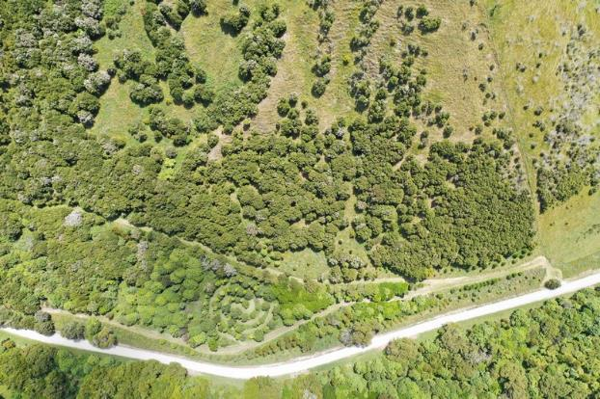
A view directly overhead of the lower slopes at Waikereru showing the planted natives along the bottom of the image and further up the hill the natural kanuka regenerating in light to dense areas. This will provide suitable sites for establishing a range of seed islands in different canopy densities.

Establishment of seed islands
Further detail on the concepts of seed islands and methods for establishment and monitoring at Waikereru Ecosanctuary are given in a work plan (Bergin and Bergin 2021). The aim is to establish a minimum of 18 seed islands over the 3-year period of the project and to plant a range of successional high forest species that will eventually provide seed for spreading across the landscape to increase the diversity of surrounding shrubland. Some additional shrub hardwood species will be planted, especially early fruiting varieties to attract birds.
Given that seed islands are relatively small, there is scope to plant at relatively high stocking of up to 4500 stems per ha (equivalent to 1.5 m plant spacing) to achieve canopy cover quickly. Wider spacing can also be undertaken but canopy cover will take more time with scope for exotic brush weed invasion unless there is a prolonged commitment to weed control.
Up to three options will be considered for establishing seed islands:
- Large gaps – planting in larger open sites surrounded by regenerating kanuka
- Partial shade – planting natives within existing scattered kanuka (Figure 4), or
- Enclosed canopy – interplanting in small gaps with kanuka that may require some clearing.
Depending on the sites available for establishing seed islands, there are various options for selection of shrub and tree species and plant spacing, for example:
- Nurse cover option – Most native tree species benefit from planting within a nurse cover of planted or existing pioneer native shrub species such as the kānuka regeneration at Waikereru. Depending on the density of the nurse cover, the aim will be to plant natives at 1.5 - 2 m apart with existing kānuka.
- Tree species groves – Alternatively, where better performance of tree species is more likely, seed islands can be established on relatively sheltered sites as groves of single or multiple tree species without a nurse cover. Most tree species are slower growing than shrubs, so tree groves ideally should be planted at a higher density to decrease the time for trees to form a closed canopy and provide some degree of mutual protection. For instance, totara, kauri and kahikatea can be planted as single-species stands on good sites without a nurse crop, but canopy closure can take one or more decades.

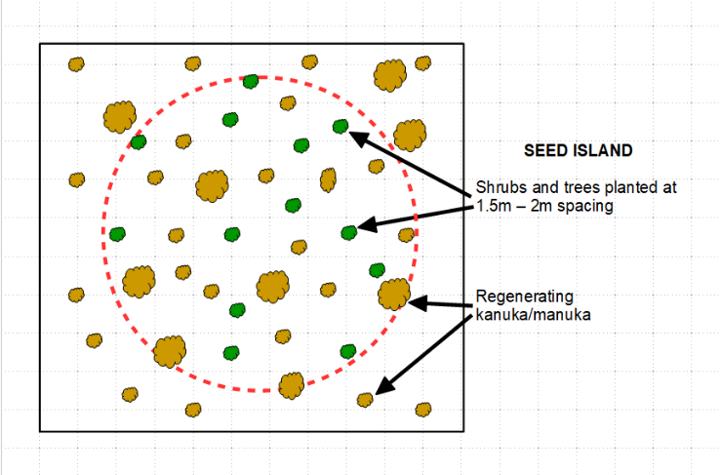
Figure 4: An example of a seed island comprising a diverse range of native shrub and tree species planted within a matrix of naturally regenerating kānuka.

Potential seed island sites
Examples of gaps, partial shade and enclosed sites as possible locations for seed islands are listed below following a reconnaissance of sites by Jeremy Salmond and Michael Bergin in December 2021. Two examples of seed island locations were identified within large gaps, partial shade and enclosed kanuka forest across the lower slopes.

- Large canopy gap example 1
- Grid reference - S38°36’23.2” E178°03’44.6”
- Size of canopy opening – 5m x 10m
- Natural kanuka 5+m height around the edges of the gap
- Some older native planting of rewarewa and totara scattered in gap, 3-4m high
- Some new plantings scattered in gap, tanekaha, 1m high. New plants have been spot-spray released and have a bamboo cane beside them
- Ground cover is dominated by dense exotic grass and some herb species

- Large canopy gap example 2
- Grid reference - S38°36’23.0” E178°03’44.2”
- Size of canopy opening – 10m x 10m
- Natural kanuka 5+m height around the edges of the gap
- No planted seedlings
- Ground cover dominated by exotic grass and herb species
- Small patch of fern in drip line of kanuka along the lower slope edge of the gap
- Blackberry patch at top of gap under the kanuka dripline
- Small kanuka regenerating in an open area within the gap approx. 0.2m height
- Small karo regenerating on the edge of the gap at the dripline of the kanuka, 0.3m height

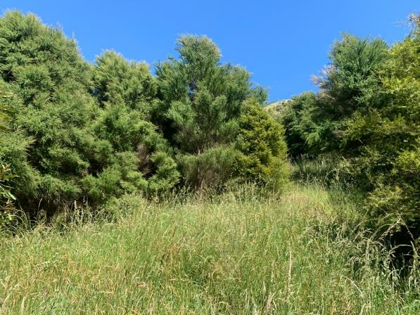
An open gap within the natural kanuka stand with exotic grasses dominating the ground.

- Partial shade example 1
- S38°36’23.5” E178°03’44.0”
- Size of potential planting site – 10m x 5m along slope
- Natural kanuka 5+m high around edge and scattered through site
- Some older planted totara and rewarewa in area 3-5m high. One rewarewa has been forced up between natural kanuka and achieved 5m height
- In the light wells there is light to medium ground cover of exotic grass and herb species
- Mosses increasing in the cover under the dense areas of kanuka

- Partial shade example 2
- S38°36’23.4” E178°03’43.7”
- Size of potential planting site – 5m x 5m
- Natural kanuka 5+m around the edges
- Light well approx. 3m x 4m
- No planted trees or seedlings in area
- Ground cover very light – mostly exotic grass and herb species
- Moss and litter cover approx. 40-50%

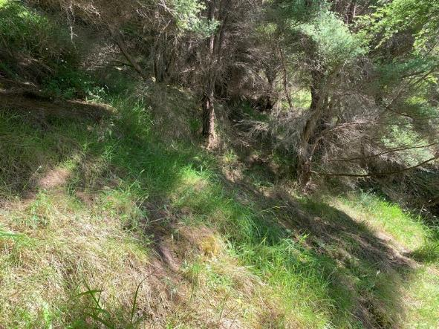
A partial shade gap where the natural kanuka is closer but still allowing light in from overhead, exotic greases and herb species are present however much less dense than the wider open gaps.

- Enclosed canopy example 1
- S38°36’23.8” E178°03’43.4”
- Size of potential planting site – 10m x 10m+
- Natural kanuka dominating the site 6+m high
- Average spacing of kanuka 1-3m
- Ground cover 95% litter and light slash
- Odd patch of exotic grass
- Understorey divaricating coprosma species over area 0.1m high
- Very dense kanuka canopy cover

- Enclosed canopy example 2
- S38°36’23.2” E178°03’44.6”
- Size of potential planting site – 10m x 10m+
- Natural kanuka across the site 5+m high
- No planted trees of seedlings
- Very dense kanuka canopy
- Ground cover 95% litter and light slash
- Ground cover species include exotic grass and herbs, carex/sedge, understorey coprosma, moss and pohuehue
- Note, numerous empty snail shells on ground

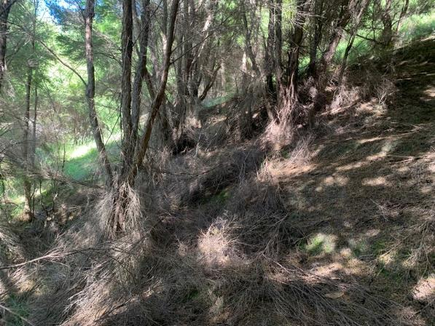
Enclosed canopy – a typical site where full canopy cover from the natural kanuka is suppressing most of the light restricting understory and ground cover growth. The ground is largely litter debris and mosses.

References
Bergin, D.; Bergin, M. 2021: Establishment of seed islands to promote regenerating native forest, Waikereru Ecosanctuary, Tairawhiti. Work plan. Tane’s Tree Trust. 14p.

Bergin, D; Sallis, R.; Kimberley, M.; Bergin, M. 2022: Guide to short-term monitoring of planted natives – field and online methods for measuring early success. Tane’s Tree Trust and Trees That Count. 15p.

